**Sample for Amazon EC2 deployed “iGo JAX-WS” (Web Service):**

WSDL: <http://54.69.0.233:8080/iGoWeb/HappyPathClientService?wsdl>

Tester: <http://54.69.0.233:8080/iGoWeb/HappyPathClientService?Tester>

**Login Sample:**

Input Parameters🡪

1. Login (Server Method)
2. Shouvik (username)
3. igo (Password)
4. true (to validate from igo users collection of mongoDb, it is true & to validate from igo users table, it is false)

Hit “getYelpData”

**Request Snapshot:** 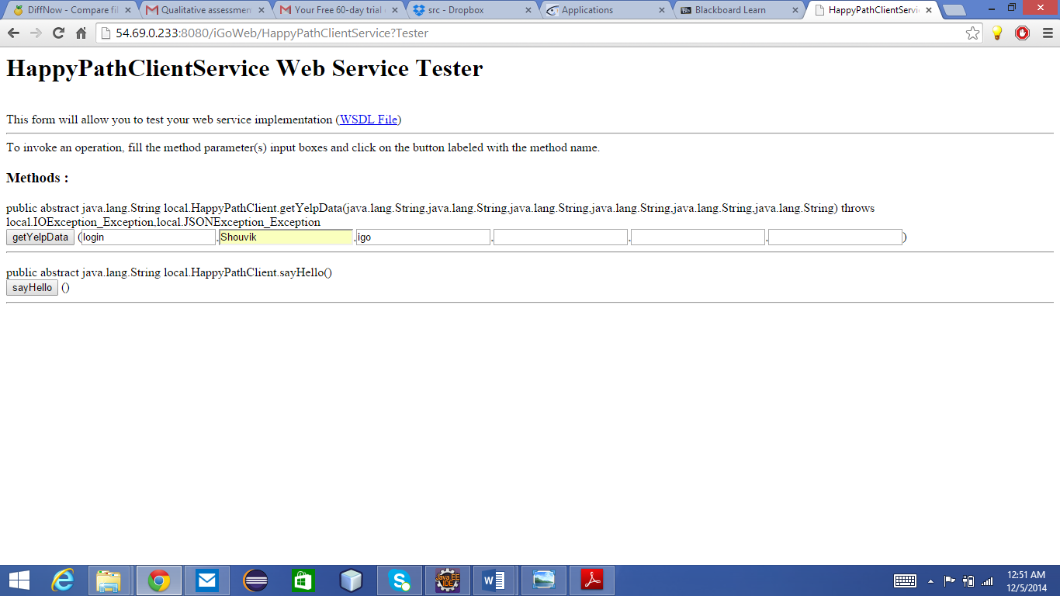

**Response Snapshot:** 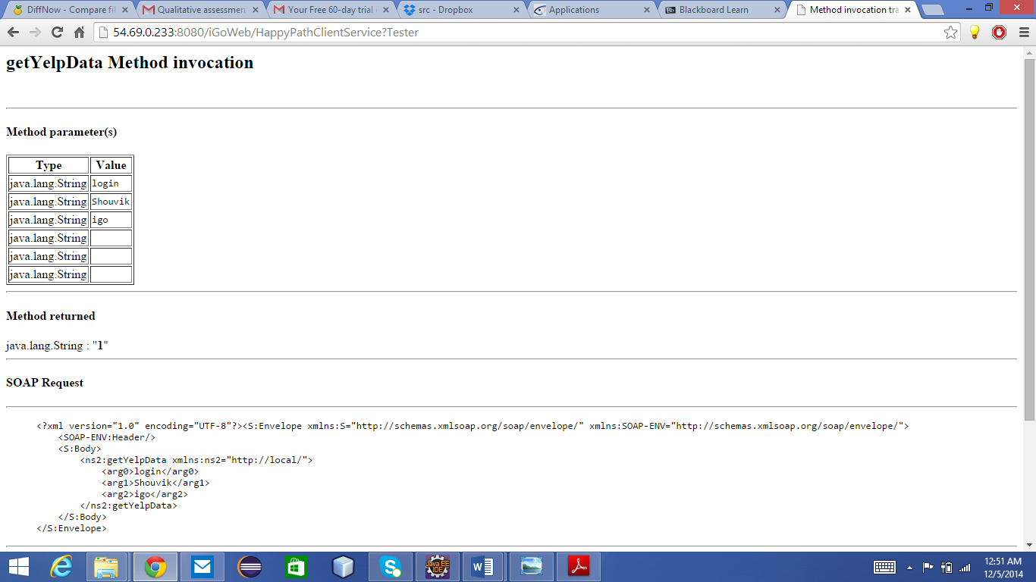

getYelpData from Yelp API sample: (This automatically populate the data from Yelp and insert into MySQL specific tables & MongoDB collections)

Input Parameters 🡪

1. getYelpData (Server Method)
2. W Taylor St (Term)
3. Chicago, IL (Location)
4. restaurants (Type, this is the table name restaurants, hospitals)

Hit “getYelpData”

**Request Snapshot:** 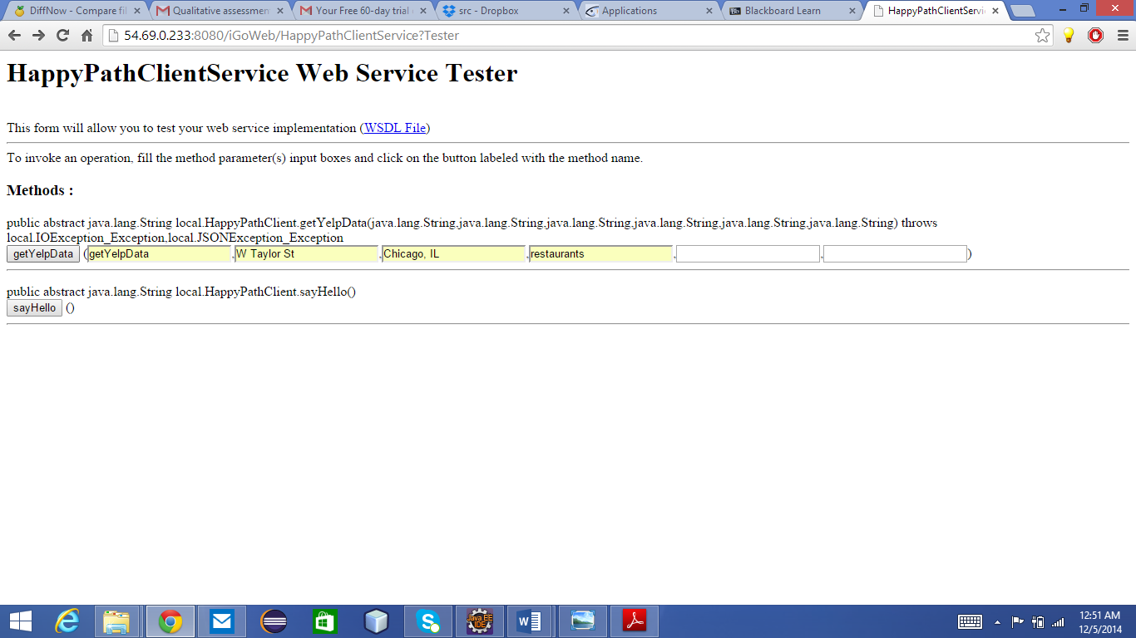

**Response Snapshot:** 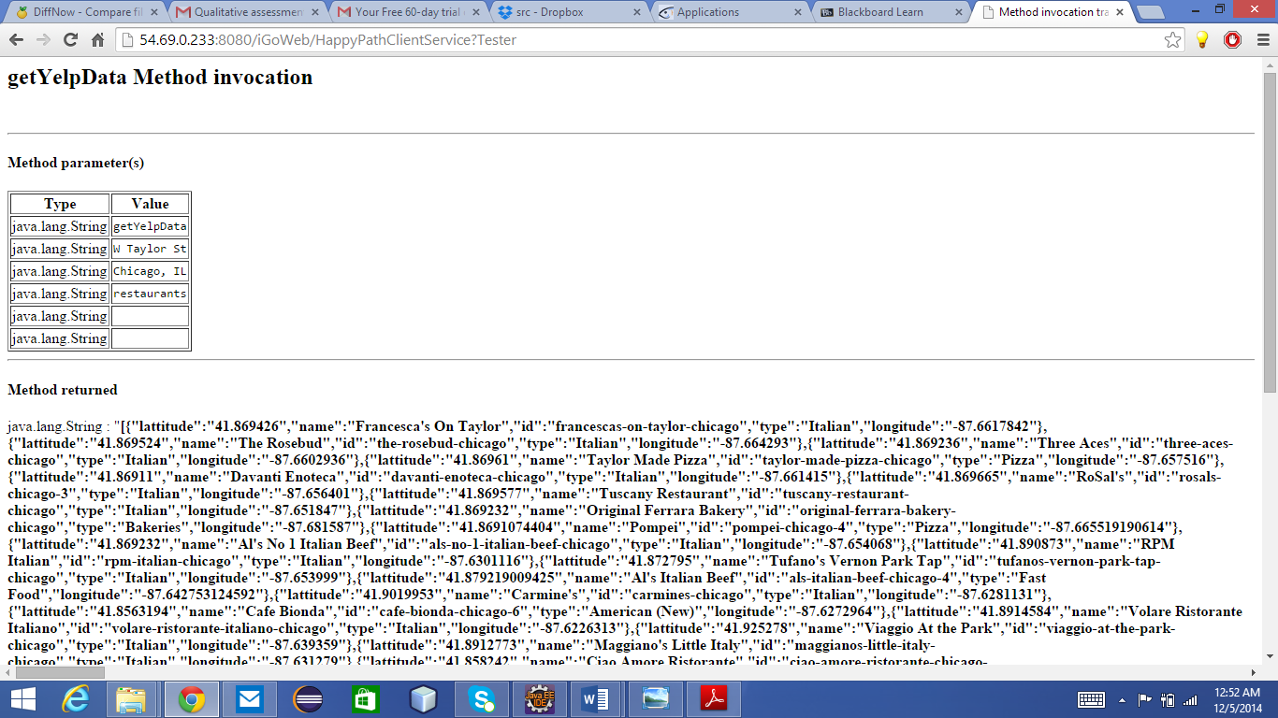

addUser to MySQL Users Table sample:

Input Parameters 🡪

1. addAccount (Server Method)
2. lgunda2 (username)
3. [lgunda2@uic.edu](mailto:lgunda2@uic.edu) (email id)
4. 7777777777 (mobile number)
5. igo (password)
6. true ( for nosql), false ( for sql)

Hit “getYelpData”

**Request Snapshot:** 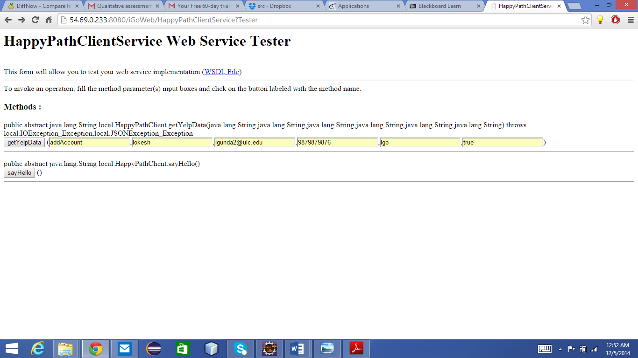

**Response Snapshot:** 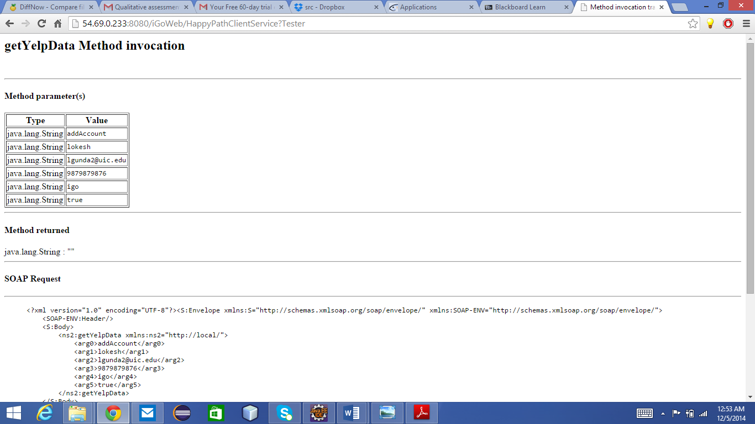

setLocation from MySQL location Table sample: (returns location id)

Input Parameters 🡪

1. setLocation (Server Method)
2. chicago (location)
3. illinois (state)
4. True ( for nosql), false ( for sql)

**Request Snapshot:** 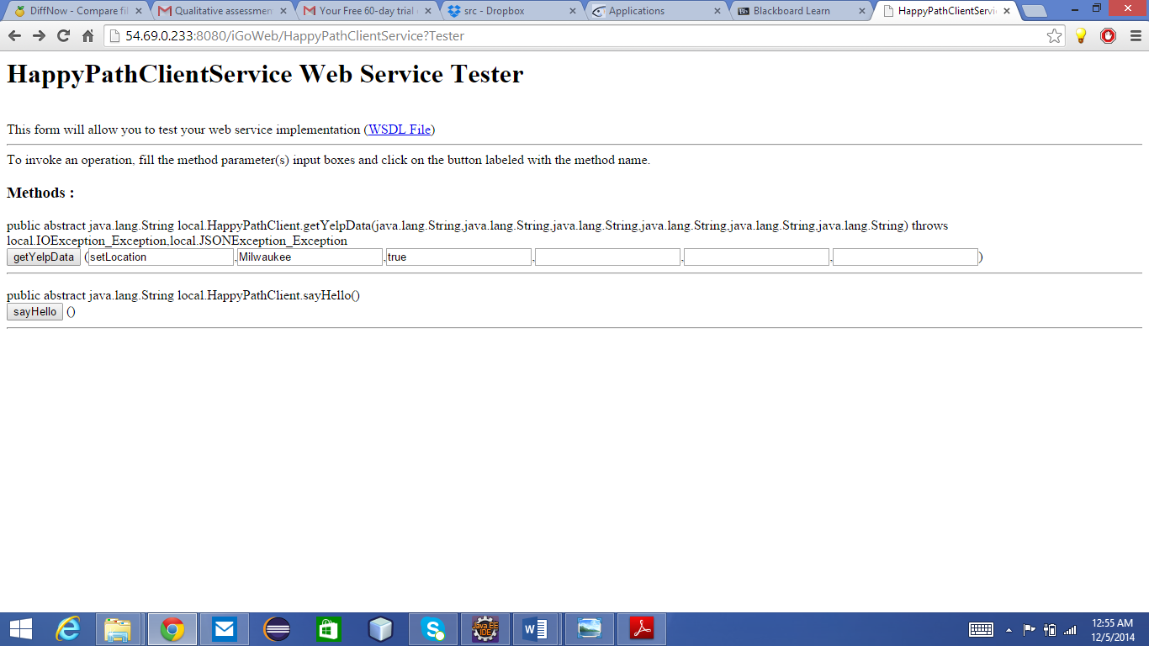

**Response Snapshot:** 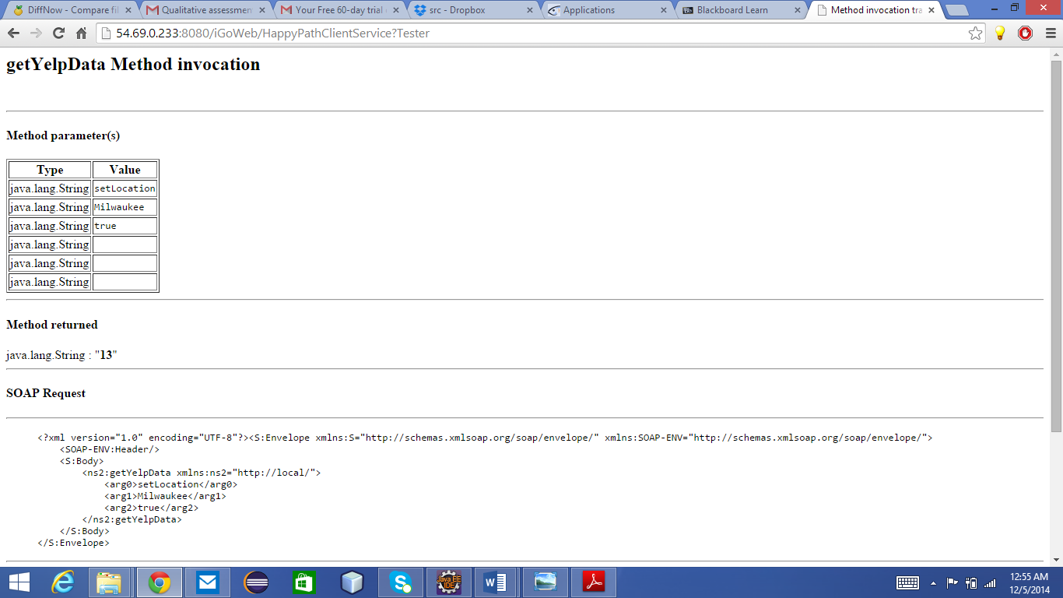

getLocations from MySQL Restaurants Table sample:

Input Parameters 🡪

1. getLocations (Server Method)
2. True ( for nosql), false ( for sql)

**Request Snapshot:** 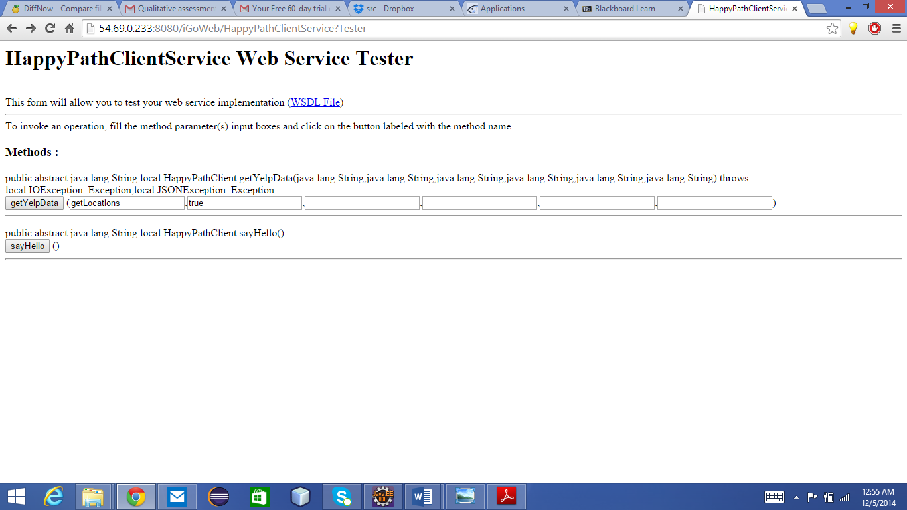

**Response Snapshot:** 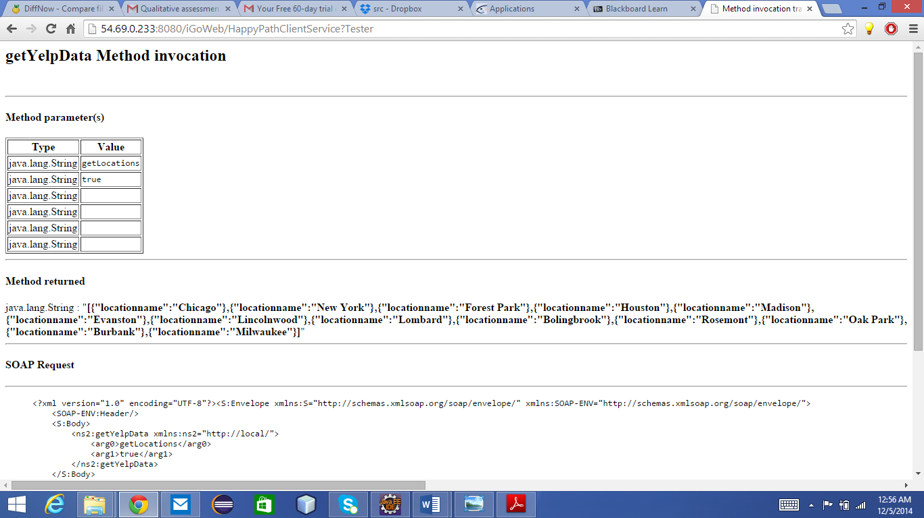

seeRestaurants from MySQL Restaurants Table sample:

Input Parameters 🡪

1. seeRestaurants (Server Method)
2. 1 (locationid)
3. True ( for nosql), false ( for sql)

**Request Snapshot:** 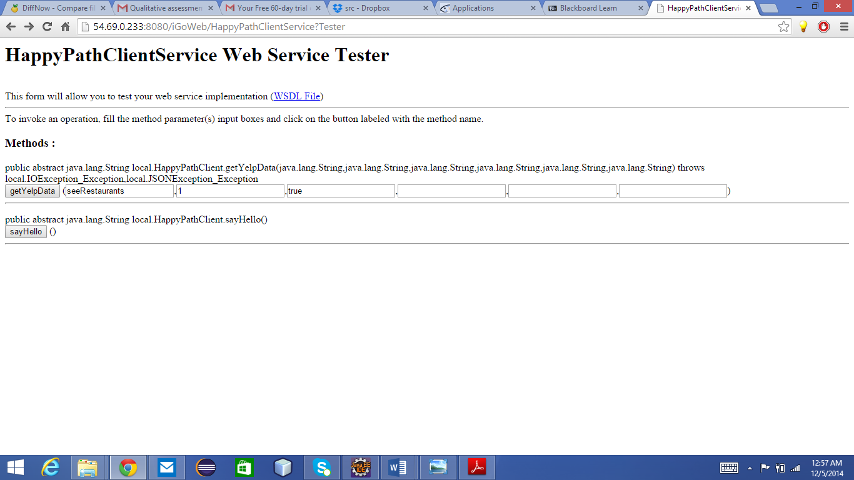

**Response Snapshot:** 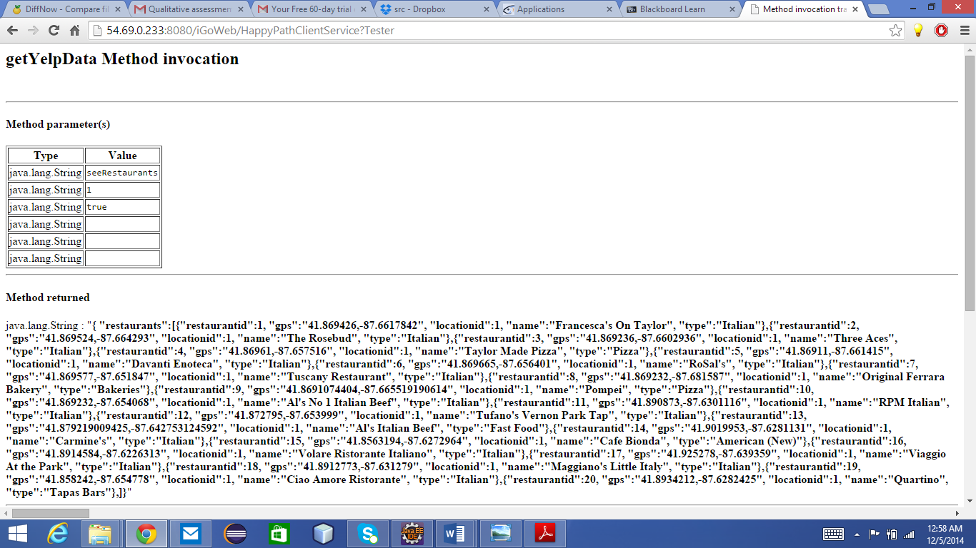

seeHospitals from MySQL Restaurants Table sample:

Input Parameters 🡪

1. seeHospitals (Server Method)
2. 1 (locationid)
3. 0 (mysql)

**Request Snapshot:** 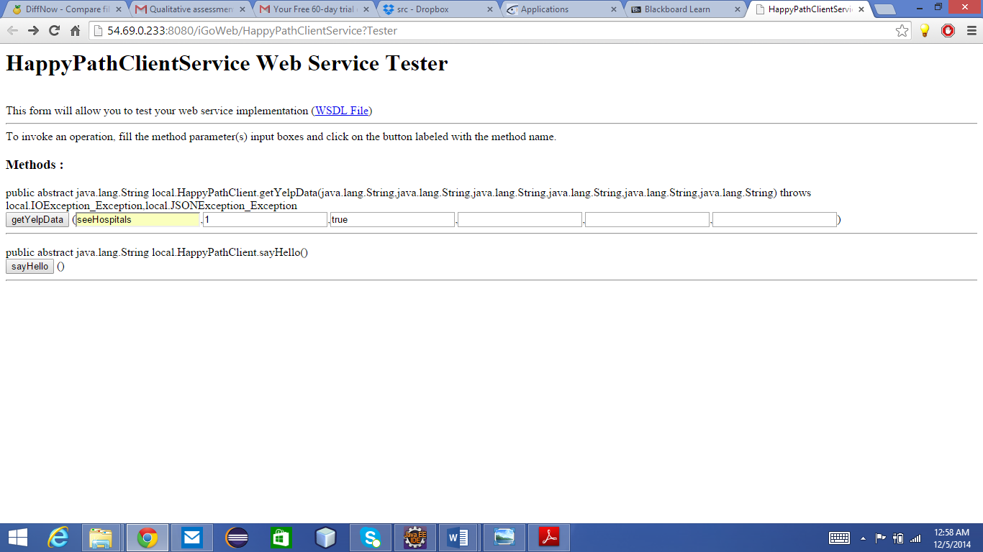

**Response Snapshot:**

